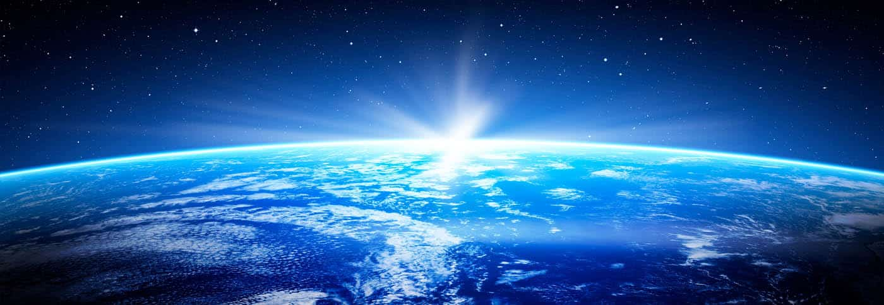

Name: Form:

MYP 2
Year 8

Earth Sciences

Glossary Earth Sciences
Word | Meaning
Abiogenesis | Is the natural process by which life arises from non-living matter,
Asthenosphere | A part of the upper mantle just below the lithosphere.
Convergent | When two tectonic plates collide and move into each other.
Divergent | When two tectonic plates move away from each other.
Era | Second largest geochronologic time unit.There are ten defined eras including the current era: Cenozoic.
Evolution | The change in the characteristics of a species over several generations
Glacial | A cold period when glaciers are expanding.
Hominim | Any member of the zoological “tribe” Hominini (family Hominidae, order Primates)
Igneous Rocks | Igneous rocks are formed through the cooling and solidification of magma or lava.
Interglacial | A warming period when glaciers and ice sheets are receding.
Lava | Hot molten or semi-fluid rock erupted from a volcano or fissure.
Lithosphere | The hard and rigid outer vertical layer of the Earth, includes the crust and the lithospheric mantle.
Magma | A hot fluid or semi-fluid material below or within the earth's crust from which lava and other igneous rock is formed on cooling.
Metamorphic Rocks | Metamorphic rocks arise from the transformation of existing rock to new types of rock in a process called metamorphism.
MYA | Million years ago.
Natural Selection | Is the survival and reproduction of individuals due to differences in physical characteristics.
Period | A smaller geochronologic time unit. Often used during the time of the dinosaurs (e.g. Jurrassic).
Sedimentary Rocks | A type of rock that is formed by the accumulation or deposition of mineral or organic particles on the Earth's surface.
Speciation | The evolutionary process by which populations evolve to become distinct species.
Subduction | When one tectonic plate slides under another, resulting in tensions and faulting in the earth's crust.

Lesson Sequence
Lesson | Content | Page
1 | The Formation of the Earth
2 | Layers of the Earth
3 | Early Stages - Volcanoes and Magma
4 | Make your own Volcano
5-6 | Criterion D - Volcanoes through time
7 | Types of Rocks and their Properties
8 | The Rock Cycle
9 | Plate Tectonics
10 | The Beginning of Life
11 | Earth’s Ages and the Dinosaurs
12 | Extinction Events
13 | Ice Ages
14 | Rise of the Mammals
15 | Evolution of Humans

8ES 1a The Formation of the Earth

Learning Objectives:
All can identify the age of the earth.
Most can develop a model of a timeline of the Earth’s formation and plot significant events on this timeline.
Some can explain how scientific theories are constantly being updated as evidence is discovered.

Introduction: Turn and Talk to a partner:
Discuss how old the following events in the Earth’s history:
How old is the Human Species?
___________________________________________________________________
___________________________________________________________________
How old is the Earth?
___________________________________________________________________
___________________________________________________________________
How old is the Solar System?
___________________________________________________________________
___________________________________________________________________
How old is the Universe?
___________________________________________________________________
___________________________________________________________________Activity 1.1 Constructing a timeline of the Earth’s Formation

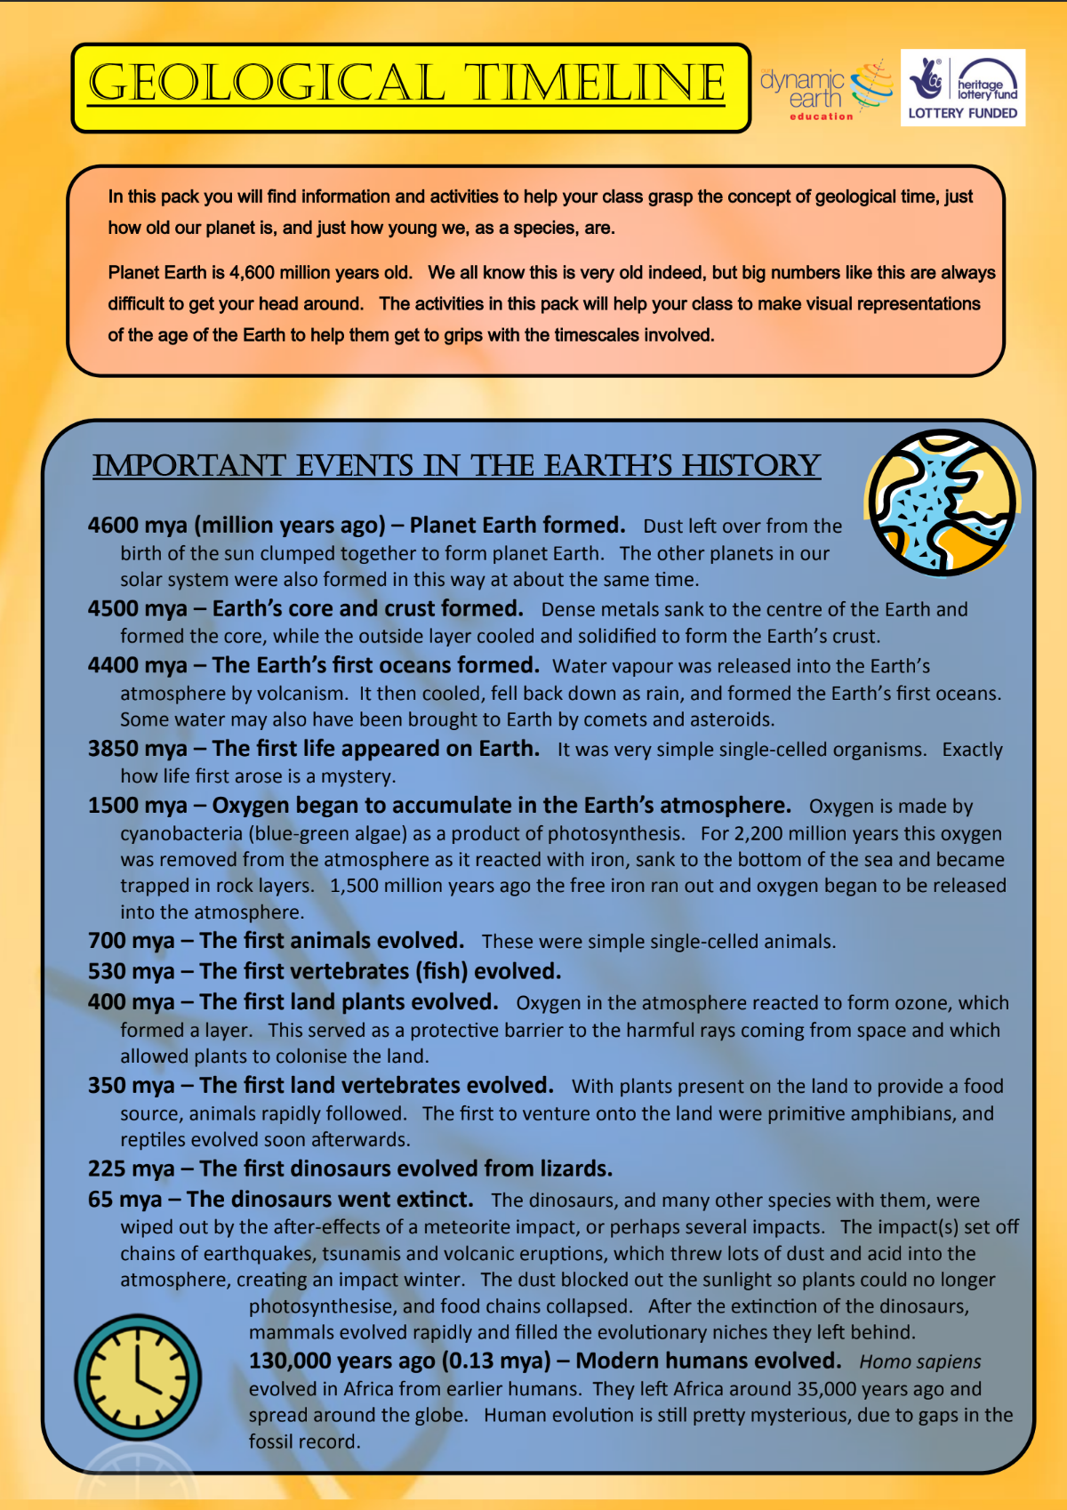

Toilet Paper Timeline Practical

Introduction:
Using the information above, construct a timeline of events of the formation of the Earth from the Formation of the Earth through to the Evolution of Modern Humans. There are 12 major events that should be included on your timeline and these have been provided to you on laminated cards.

Method:

- Carefully unwind your roll of toilet paper and tape it down to the space you are working in. It is important you do your best not to tear the toilet paper.
- Count the total number of sheets of toilet paper.
- Divide the age of the earth (4600 million years ago) by the number of sheets of toilet paper to find the value of one sheet.
- Working from the formation of the Earth, add the laminated events in the appropriate places along your timeline.
- Research three additional events that took place and add these as an illustration to your timeline. Some suggested examples could be the creation of the moon? The First Volcanic Eruption? The evolution of the banana plant? Etc.
- Once you have finished, please use a mobile phone to shoot a short video that runs down the length of your timeline and pauses at each major event to describe it. This can be uploaded to google classroom.
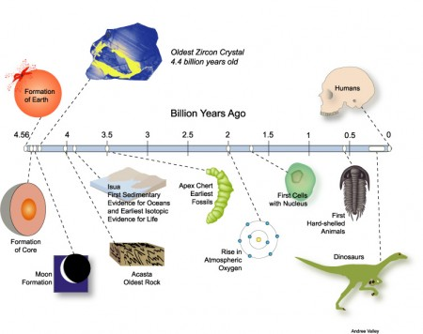

Research Opportunity

*If you want to deepen your understanding of this topic here is an additional research opportunity and some useful websites you could use.

The British Geological Survey website has some very good information on geological time. There is an interactive online timeline and teachers’ notes with more events you could choose to include in your timeline.
http://www.bgs.ac.uk/discoveringGeology/time/timeline/home.html

The Science Education Resource Centre has further information on making a toilet paper timeline.
http://serc.carleton.edu/quantskills/activities/TPGeoTime.html

This pack links in nicely with the James Hutton and Charles Lyell packs, also provided by Dynamic Earth Education. For more information see the Dynamic Earth website support materials section.
http://www.dynamicearth.co.uk/learning/curriculum-for-excellence/support-materials

There is a very good free app called EarthViewer that lets users explore different aspects of the Earth’s deep history, including plate tectonics, climate and fossils.

http://www.hhmi.org/biointeractive/earthviewer

Something interesting I learnt from my own research was:

______________________________________________________________________________________________________________________________________________________________________________________________________________________________________________________________________________________________________________________________________________________________________________________________________________________________________________________________________________________________________________________________________________________________________________________________________________________________________________________________________________________________________________________________________________________________________________

8ES 2a Layers of the Earth

Mountain ranges tower to the sky. Oceans plummet to impossible depths. Earth’s surface is an amazing place to behold. Yet even the deepest canyon is but a tiny scratch on the planet. To really understand Earth, you need to travel 6,400 kilometers beneath our feet.
Starting at the centre, Earth is composed of four distinct layers. They are, from deepest to shallowest, the inner core, the outer core, the mantle and the crust. Except for the crust, no one has ever explored these layers in person. In fact, the deepest humans have ever drilled is just over 12 kilometers. And even that took 20 years!
Still, scientists know a great deal about Earth’s inner structure. They’ve plumbed it by studying how earthquake waves travel through the planet. The speed and behaviour of these waves change as they encounter layers of different densities. Scientists — including Isaac Newton, three centuries ago — have also learned about the core and mantle from calculations of Earth’s total density, gravitational pull and magnetic field.

Geiger, B. (2019, November 11). Explainer: Earth — layer by layer. Science News, Explores. Retrieved October 31, 2023, from https://www.snexplores.org/article/explainer-earth-layer-layer
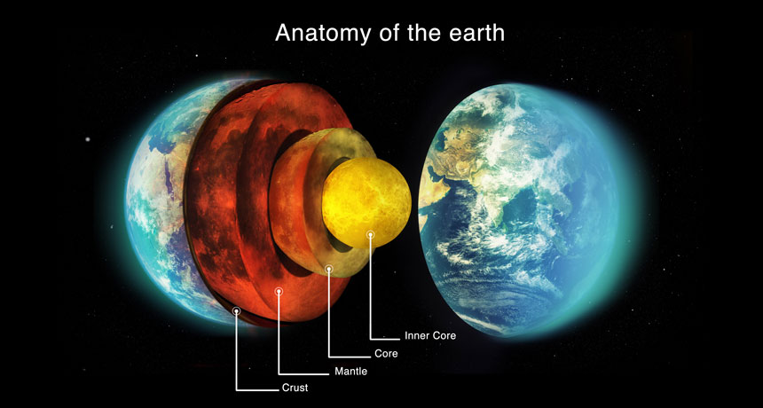
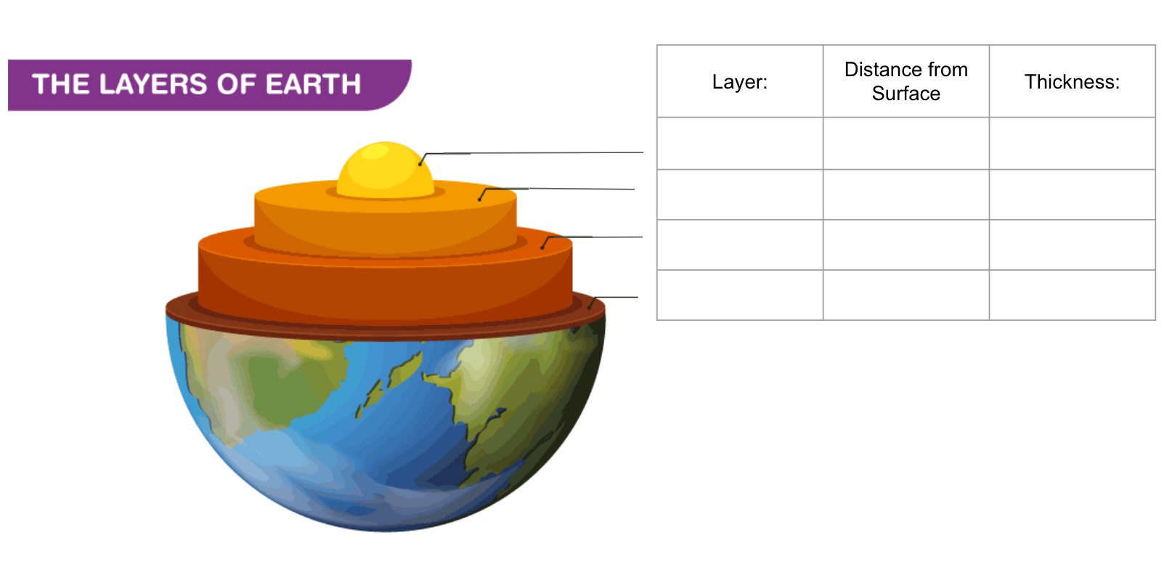
Earth's crust ranges from ____________ in depth and is the outermost layer. Oceanic crust is more dense than ____________ crust which causes it to slide beneath the continental crust when they meet. This rubbing causes ____________. There are several large pieces of continental crust called ___________ _________ that move very slowly.
At almost 3000 km thick, the ____________ is the earth’s thickest layer. It is very dense and hot and also only ____________, which means it circulates slowly around the earth.
The core is made up of the inner core and outer core and is mostly made of ____________ and ____________. These are heavy metals which is why they ____________ to the centre of the earth and formed the core. The inner core is solid, while the outer core is ____________ and also circulates around the earth.

5 - 70 Km continental earthquakes tectonic plates mantle semi-solid Iron Nickel sank liquid

8ES 2b Creating a Model of the Earth

Option 1: Modelling Clay  Apparatus:  At least 4 colours of clay  Flag toothpicks  Method:  - Make a small ball with one colour of clay  - Wrap another layer of different colour clay  - Wrap 2 more layers of different colour clay  - Cut out a wedge to show all 4 layers of the earth.  - Using flag toothpicks (or string with paper), list out all relevant information for each layer.  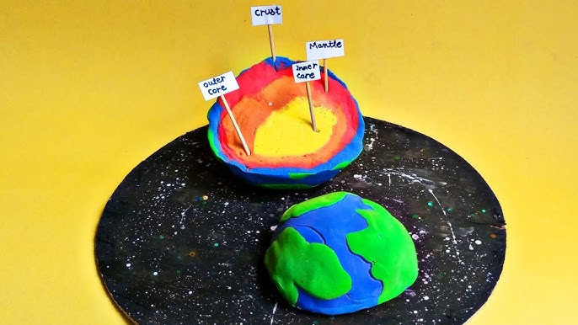 | Option 2: Coloured Paper  Apparatus:  At least 4 colours of paper  String  Method:  - Cut out 4 circles of paper of increasing diameter representing each layer of the earth.  - Glue each layer on top of the other, starting with the biggest and working down to the smallest.  - Stick string on each layer and connect to another piece of paper.  - For each layer list relevant information.  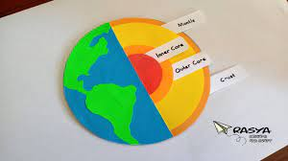

Extension: Research and add to the model the Lithosphere and Asthenosphere, the depth and thickness as well as the purpose.

8ES 3a Early Stages of the Earth - Volcanoes and magma

In Earth's Beginning
At its beginning, Earth was unrecognizable from its modern form. At first, it was extremely hot, to the point that the planet likely consisted almost entirely of molten magma. Over the course of a few hundred million years, the planet began to cool and oceans of liquid water formed. Heavy elements began sinking past the oceans and magma toward the center of the planet. As this occurred, Earth became differentiated into layers, with the outermost layer being a solid covering of relatively lighter material while the denser, molten material sunk to the center.
Scientists believe that Earth, like the other inner planets, came to its current state in three different stages. The first stage, described above, is known as accretion, or the formation of a planet from the existing particles within the solar system as they collided with each other to form larger and larger bodies. Scientists believe the next stage involved the collision of a protoplanet with a very young planet Earth. This is thought to have occurred more than 4.5 billion years ago and may have resulted in the formation of Earth’s moon. The final stage of development saw the bombardment of the planet with asteroids.
Earth’s early atmosphere was most likely composed of hydrogen and helium. As the planet changed, and the crust began to form, volcanic eruptions occurred frequently. These volcanoes pumped water vapor, ammonia, and carbon dioxide into the atmosphere around Earth. Slowly, the oceans began to take shape, and eventually, primitive life evolved in those oceans.
Formation of Earth. (n.d.). National Geographic Society. Retrieved November 7, 2023, from https://education.nationalgeographic.org/resource/formation-earth/
Geiger, B. (2019, November 11). Explainer: Earth — layer by layer. Science News Explores. Retrieved October 31, 2023, from https://www.snexplores.org/article/explainer-earth-layer-layer
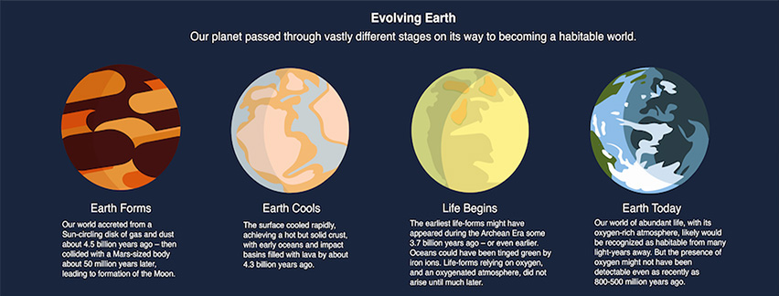

8ES 3b Questions
1. How old is the earth? How do we know?:_______________________________________
______________________________________________________________________________________________________________________________________________________
2. Scientists believe the moon was formed during the second stage of earth's development. How do they think this happened ?______________________________________________
______________________________________________________________________________________________________________________________________________________
3. Why was the early earth hot?_________________________________________________ ______________________________________________________________________________________________________________________________________________________
4. What minerals make up the earth’s crust? And why is this so? ______________________________________________________________________________________________________________________________________________________
5. List at least 3 gases released by volcanoes in the early formation of earth?_____________________________________________________________________
______________________________________________________________________________________________________________________________________________________
6. When did the continents form and why does the continental crust rise above the oceanic crust?
_________________________________________________________________________________________________________________________________________________________________________________________________________________________________

8ES 3C Volcanoes and Magma
Using the space below draw and annotate a volcano. Make sure you list as much information as you can. You should have such features as magma, lava, crater, secondary side vent, gases etc.

Extension: Research and list different types of volcanoes, their primary differences and examples around the world /OR/ Research historic volcanic eruptions: when they occurred and their impact.

8ES 4a Making your own Volcano
Types of Volcanoes
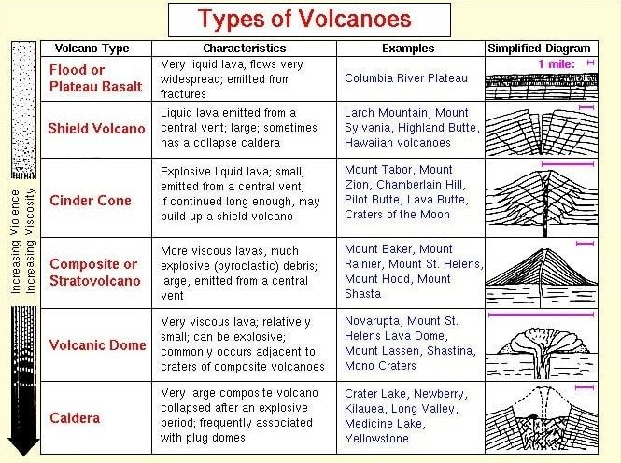

Looking the above examples, in groups of 3 or 4 - choose a type of volcano to make using the instructions below. You can watch this video for tips:
How to make a volcano: A super quick and easy project | Natural History Museum

Apparatus:
You will need the following items:
- Two A3 sheets of card  - 500 ml plastic bottle  - Scissors  - Tape  - Paint and paintbrushes | - 3 tbsp bicarbonate of soda (baking soda)  - 3 tbsp washing up liquid  - 180ml water  - 1.5 cups vinegar  - 2 tbsp red food colouring
Method:
- Place your bottle upside down in the centre of a sheet of card and draw a small circle around the neck. Cut a straight line through the card to the middle of the circle, and cut out the circle.
- Overlap the two sides of the card to make a cone shape. Tape this into place, leaving a hole where you cut out the circle and cut around the base of the cone so that it sits flat, but make sure that it is still taller than your bottle. Tape the base of the cone to the other sheet of card.
- Use paint to decorate the cone and make it look like a volcano. Allow your model to dry.
- In a bowl, combine the bicarbonate of soda and washing up liquid. Add the water and mix thoroughly. Pour this mixture into your volcano.
- In a cup, mix together the vinegar and food colouring.
- When you're ready, pour the vinegar into the bottle with the bicarbonate. Wait for it to erupt and watch how the lava flows.

8ES 4b Follow Up Questions
1. What type of volcano did you make?
____________________________________________________________________________
__________________________________________________________________________________________________________________________________________________________2. Why did your volcano erupt? ____________________________________________________________________________
__________________________________________________________________________________________________________________________________________________________
3. When did your ‘magma’ become ‘laval’? ____________________________________________________________________________
__________________________________________________________________________________________________________________________________________________________
4. How would you improve your volcano for next time? _____________________________________________________________________________
__________________________________________________________________________________________________________________________________________________________
__________________________________________________________________________________________________________________________________________________________


MYP 2: Year 8 Science
Criterion D Assessment - Reflecting the Impacts of Science

UNIT: | Earth Science
ASSESSMENT TITLE: | Volcanos through time
Inquiry Statement | Exploring relationships in the environment that result from interactions between organisms.
Key Concept: | Relationships
Related Concepts: | Environment, Interaction
Assignment Instructions (GRASPS)
Goal | Produce a Newscast that would be on the 6 o'clock news explaining about a volcano that is currently erupting.
Role | You must work on this task in groups of FOUR.  Each person in the group will assume a different role from the following list;  - News anchor  - Science specialist  - Weather meteorologist  - Environmentalist
Audience | Global News Network
Situation | A volcano has just erupted and is spewing hot ash and lava into the air. Citizens are panicking and are looking for news about the impacts on their lives and global affairs this type of eruption might cause.
Product | Produce a group Newcastin which you discussA famous volcanic eruption from time. The Newscast should be no more than a TOTAL of 5 minutes in length, allowing each member of your group to provide a 1min 20s segment. Try and imitate a traditional newscat you might see in an emergency situation.
Success Criteria for Assessment | In your podcast you will:  - Clearly explain the local and global impact that a volcanic eruption can have  - You refer to data to support your argument and facts presented.  - You must use accurate scientific terminology in your verbal communication in the Newscast.  - Your Newscast should be factually accurate and based on valid historic and scientific data. Sources must be cited.
Other Information: You MUST provide a Bibliography and cite all your sources.
Due Date: this will be set by your teacher.

Level Descriptors and Task Specific Clarifications for Criterion D:
Level | Level Descriptor | Task Specific Clarification
0 | The student does not reach a standard described by any of the descriptors below. | No data or clear evidence provided.
1-2 | The student is able to, with limited success:  i. state the ways in which science is used to address a specific problem or issue  ii. state the implications of using science to solve a specific problem or issue, interacting with a factor  iii. apply scientific language to communicate understanding  iv. document sources. | ii. Student simply state there is a volcano erupting and do not provide information specific to the volcano chose  ii. Lack data to underpin their arguments or points discussed..  iii. Little evidence of scientific vocabulary being used.  iv. Source of information given, but not correctly referenced.
3-4 | The student is able to:  i. Outline the ways in which science is used to address a specific problem or issue  ii. Outline the implications of using science to solve a specific problem or issue, interacting with a factor  iii. sometimes apply scientific language to communicate understanding  iv. sometimes document sources correctly. | i. A specific example of a volcano is chosen and data provided is valid to their specific example  ii. Students provide at least 1 point of view from a specialist on the impacts of a volcanic eruption of this scale  iii. Some scientific vocabulary is used.  iv. Bibliography has only three sources referenced, but this may not be accurately formatted.
5-6 | The student is able to:  i. Summarize the ways in which science is used to address a specific problem or issue  ii. Describe the implications of using science to solve a specific problem or issue, interacting with a factor  iii. usually apply scientific language to communicate understanding clearly and precisely  iv. usually document sources correctly. | i. The chosen volcano is contextualized into its specific time period and the students identify the impacts it would have had.  ii. Multiple points of view are evaluated and describe by specialists on the newscast  iii. Some good scientific vocabulary is used.  iv. At least 5 sources are referenced in APA format
7-8 | The student is able to:  i. Describe the ways in which science is applied and used to address a specific problem or issue  ii. Describe and summarize the implications of using science and its application to solve a specific problem or issue, interacting with a factor  iii. consistently apply scientific language to communicate understanding clearly and precisely  iv. document sources completely | i. The Volcano is described in context to its time period. The economic, scientific, environmental impacts are considered and explained during the newscast by students.  ii. Comparison to more modern volcanic impacts included  iii. Explanations involve excellent scientific vocabulary.  iv. Correct bibliography is provided citing at least 5 reputable and relevant sources, in APA format. Sources are also referenced in the script using APA format.

8ES 7a Types of Rocks and their Properties

What do you know about rocks?

Have you seen different types of rocks? What makes them different?

The crust is the Earth's outer layer and is made of rocks. Rocks are solids which are made of grains of minerals which fit together.
Minerals are chemical compounds which occur naturally in the Earth’s crust. A compound is a substance which is made from two or more elements which are chemically bonded together in a fixed ratio of atoms.
Rocks can be classified into three types depending on what minerals they contain and how they are formed.
The three types of rock are:
- Igneous
- Metamorphic
- Sedimentary

Rock types - The Earth and atmosphere - KS3 Chemistry - BBC Bitesize. (n.d.). BBC. Retrieved January 8, 2024, from https://www.bbc.co.uk/bitesize/articles/zpygcmn#zb9wqfr

8ES 7b Types of Rocks and their Properties

 | Igneous | Sedimentary | Metamorphic
How are they formed
Diagram of Formation
Characteristics
Examples

8ES 7c Properties of Rocks and Classification
Practical: Properties of Rocks
Collect a sample of rocks, including examples of igneous, sedimentary, and metamorphic rocks. Observe and explore the samples using hand lenses or magnifying glasses.

Identify and describe the following properties of rocks:

Colour: What is the predominant colour of the rock?

Texture: Is the rock rough, smooth, grainy, or glassy?

Hardness: Can the rock be scratched with a fingernail, penny, or other objects?

Composition: Does the rock contain visible minerals or fossils?

Weight: Is the rock heavy or lightweight?

Other properties: Aspects like transparency, magnetism, or smell (if relevant).

Activity: Rock Classification

- Divide into small groups of 3-4.

- Using paper and markers: create a classification chart to organise the rock samples into the three main types: igneous, sedimentary, and metamorphic.

- Write the properties of each rock type under the respective categories on the chart paper.

8ES 8 The Rock Cycle

Learning Objectives:
All are able to describe the structure of igneous, sedimentary and metamorphic rock
Most can explain the process of the rock cycle and know how rock can be changed from one type to another.
Some can explain how geographic regions favour the production of certain types of rock.

Introduction: Recap of the types of rock
What are the physical properties of sedimentary rock
____________________________________________________________________
____________________________________________________________________
Where does igneous rock get produced?
____________________________________________________________________
____________________________________________________________________
Give an example of a type of metamorphic rock
____________________________________________________________________
____________________________________________________________________
Activity 1.1 The Choc Rock Cycle

We are going to build a model of the Rock Cycle using chocolate to explain and simplify some of the complicated processes.

8ES 9a Plate Tectonics

Plate tectonics is a scientific theory that explains how major landforms are created as a result of Earth’s subterranean movements. The theory, which solidified in the 1960s, transformed the earth sciences by explaining many phenomena, including mountain building events, volcanoes, and earthquakes.
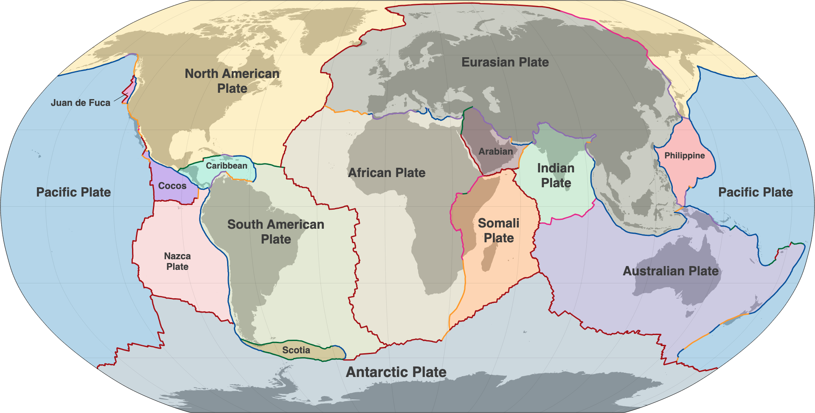

In plate tectonics, Earth’s outermost layer, or lithosphere—made up of the crust and upper mantle—is broken into large rocky plates. These plates lie on top of a partially molten layer of rock called the asthenosphere. Due to the convection of the asthenosphere and lithosphere, the plates move relative to each other at different rates, from two to 15 centimeters (one to six inches) per year. This interaction of tectonic plates is responsible for many different geological formations such as the Himalaya mountain range in Asia, the East African Rift, and the San Andreas Fault in California, United States.

Gerster, G. (2023, October 19). Plate Tectonics. National Geographic Society. Retrieved January 10, 2024, from https://education.nationalgeographic.org/resource/plate-tectonics/

8ES 9b Plate Boundaries

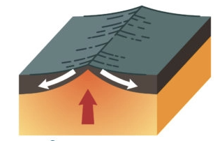
Under each picture, give the name of the plate boundary and describe its motion. Then draw a line to where it occurs on the picture below:
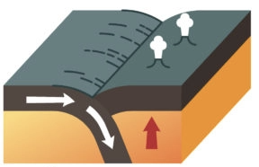
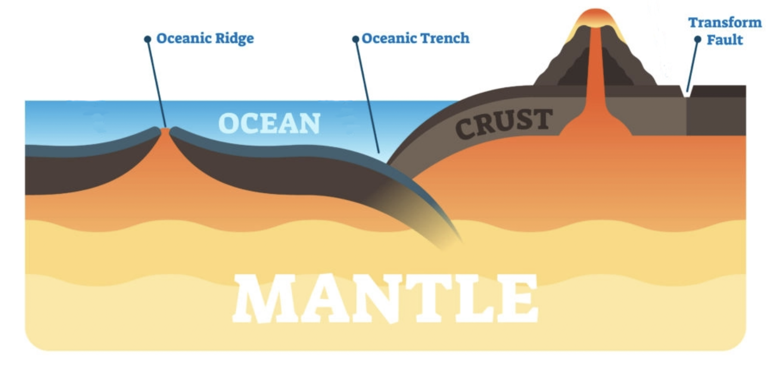
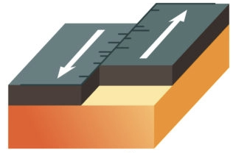

8ES 9c Earthquake Proofing
Faults are fractures in Earth’s crust where movement has occurred. Sometimes faults move when energy is released from a sudden slip of the rocks on either side. Most earthquakes occur along plate boundaries along the faults.

Practical: Earthquake Proofing
Research:
- Conduct research on different types of earthquake-resistant structures (e.g., base isolation, damping systems, and triangular bracing).
- In small groups, discuss and sketch out their ideas for an earthquake-proof structure.
- Consider the materials, design, and construction techniques that will enhance the structure's stability

Construct:
- Using the provided materials work in groups to build your designs, following your initial sketches and incorporating your chosen materials.

Test:
- Your teacher will now test your construction through a simulated Earthquake!
- Observe and record the performance of each structure during the simulated earthquake. Note any signs of collapse, deformation, or stability.

8ES 9c Earthquake Proofing
Use this page for initial sketches and designs:

Observations and Analysis after testing:

8ES 10a The Beginning of Life

How do you think life on Earth started? Be as descriptive as possible in your answer below:

The Greek philosopher Aristotle (384–322 BC) was one of the earliest recorded scholars to articulate the theory of spontaneous generation, the notion that life can arise from nonliving matter. Aristotle proposed that life arose from nonliving material if the material contained pneuma (“vital heat”). As evidence, he noted several instances of the appearance of animals from environments previously devoid of such animals, such as the seemingly sudden appearance of fish in a new puddle of water.
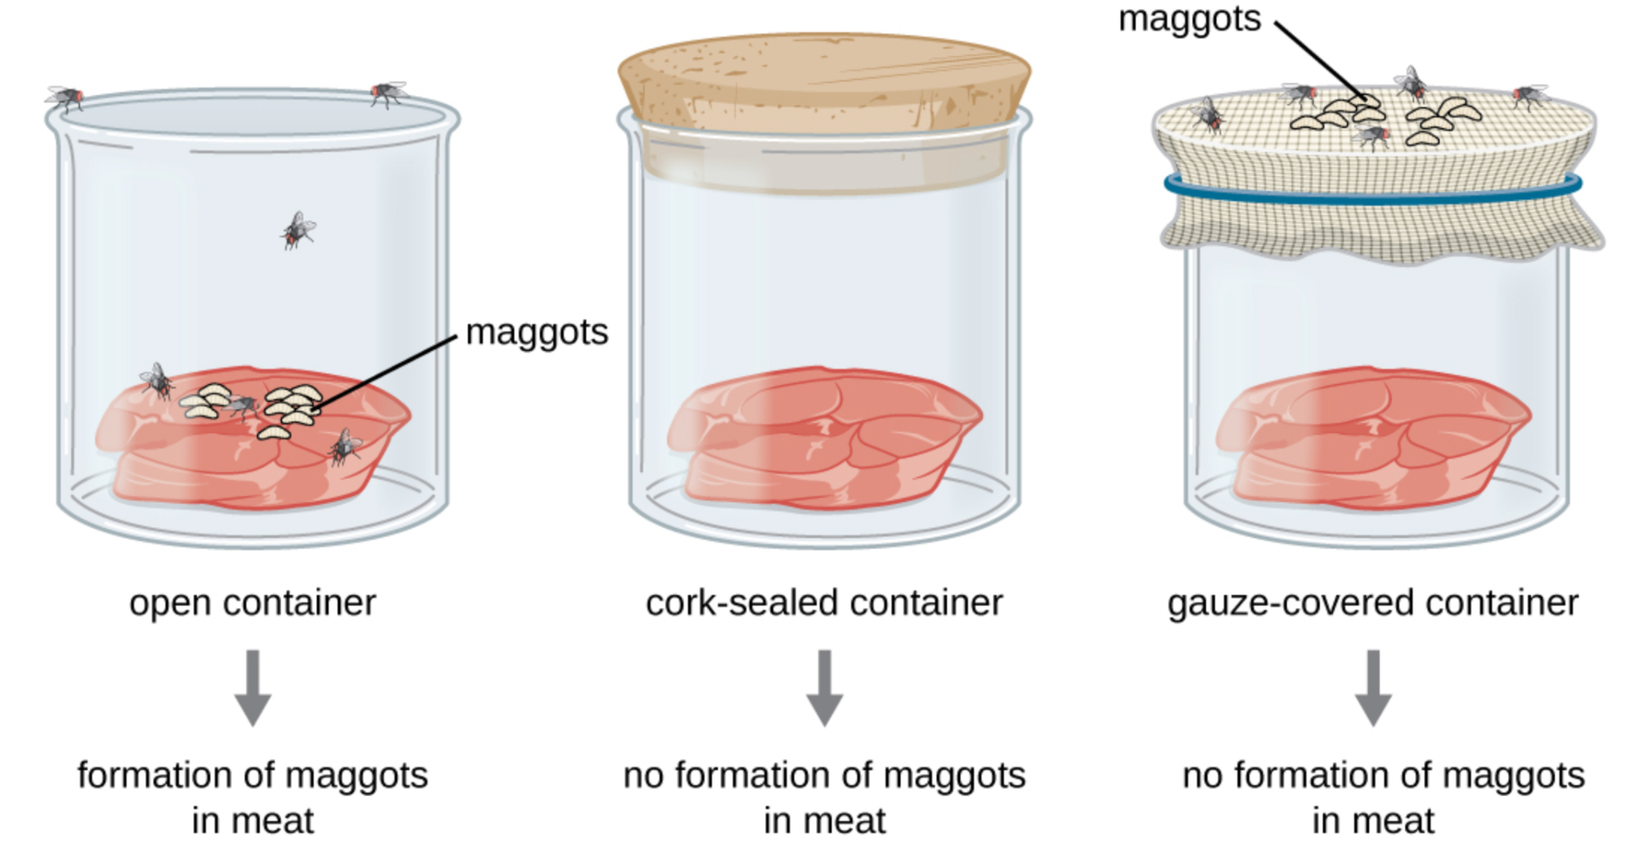
Francesco Redi’s (1626–1697) experiment disproving spontaneous generation

The idea that life can be distributed throughout the universe, from planet to planet, is called panspermia.

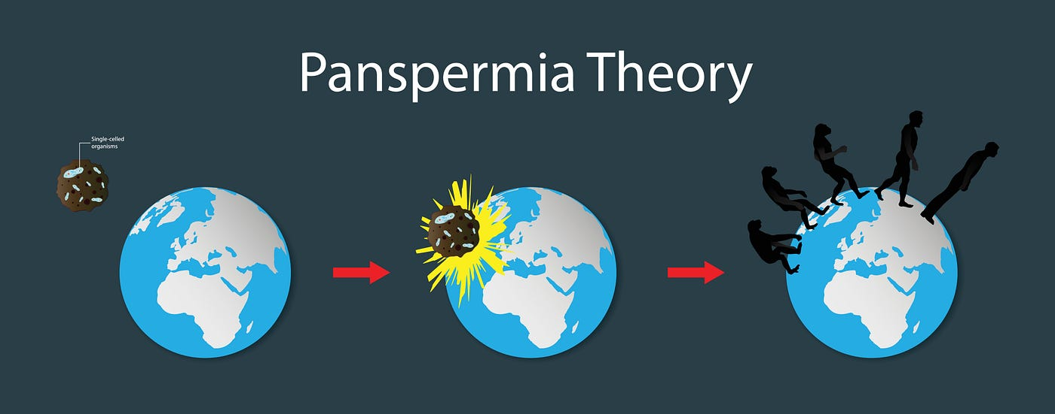

Place Evidence in the Correct Column

Supports Panspermia | Does not support Panspermia

- Interstellar dust is largely organic sugar molecules including ribose detected in meteorites
- Meteorites can be contaminated with organic molecules as it enters earth’s atmosphere
- Space has extreme temperatures and pressures that are unforgiving to most life forms
- There is no known life on other planets.
- Some microorganisms can survive in lab created simulations of space

8ES 10b Abiogenesis

Abiogenesis, is the scientific concept that proposes how life could have originated from ____________. According to the ___________ theory, early Earth's oceans contained a mixture of organic molecules that gradually formed more complex compounds.

Simple organic molecules, such as ___________ and nucleotides, could have come together to form more complex organic compounds. The process of abiogenesis suggests that over time, the concentration and complexity of these organic molecules ___________.

Abiogenesis is distinct from the theory of ___________, which explains how life has diversified and changed over time.

Another hypothesis related to the origin of life is the ___________ theory, which proposes that life on Earth may have originated from microorganisms or organic molecules that arrived from space.

It was thought that ____________ and ____________ provided energy necessary to arrange simple molecules of into the basic building blocks of organic compounds

Early life forms were continuously bombarded by UV radiation, causing _________ that produced new life forms

Increased Non-living matter Lightning storms

primordial soup amino acids panspermia

Mutations UV radiation evolution

8ES 10c Miller-Urey Experiment
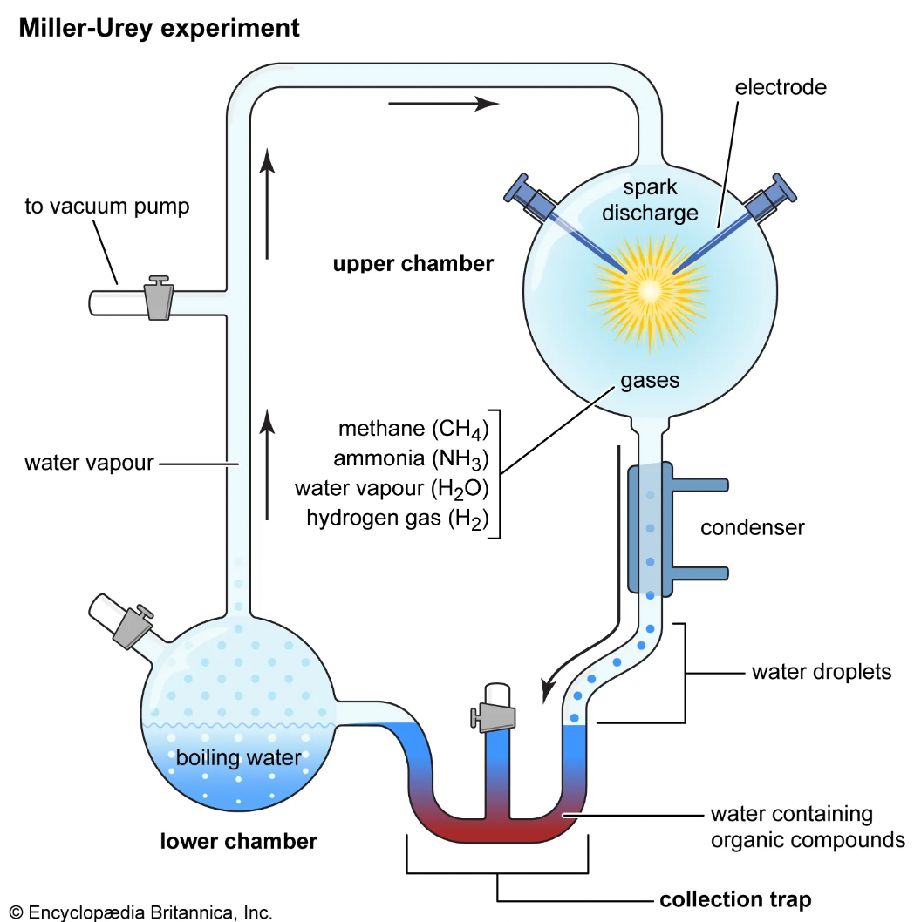
Draw a line from the
experiment to what
it simulates below:

Ancient Oceans

Ancient atmosphere

Lightning Storms

Place Evidence in the Correct Column

Supports Abiogenesis | Does not support Abiogenesis
- Primitive earth’s atmosphere was extremely hot and electrically charged
- Geological Evidence suggests that earth’s atmosphere was not the same as the Miller-Urey Experiment
- Miller and Urey created a simulation of earth’s atmosphere and found that biomolecules had formed within just one week.

8ES 10d Life in a drop of Seawater
Practical: Life in a drop of Seawater
Activity:
- Look at one drop of seawater under a microscope at different magnifications
- Draw what you observe below

Magnification:
Magnification:

8ES 11a Earth’s Ages and the Dinosaurs

Using the National Geographic infographic design your own flow chart of the different geological era’s below:
(https://education.nationalgeographic.org/resource/age-earth/)

8ES 11b Dating Rocks and Fossils

Define Relative Dating:

Define Absolute Dating:

Relative Dating:
Organise the family below into order of oldest to youngest:
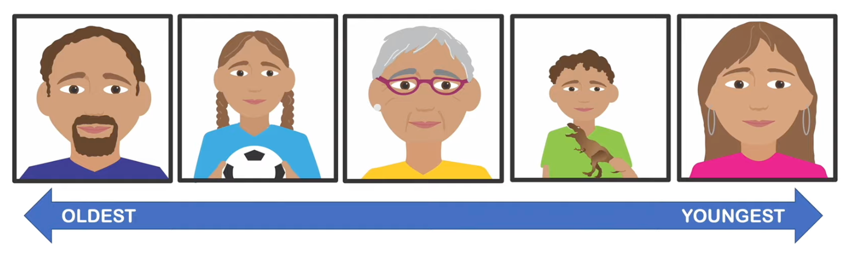

As shown in the diagram, fossils found in lower strata were deposited earlier and thus must be older than fossils in higher strata (this principle is known as superposition).

Chronology. (n.d.). Understanding Evolution. Retrieved February 26, 2024, from https://evolution.berkeley.edu/lines-of-evidence/distribution-in-time-and-space/chronology/

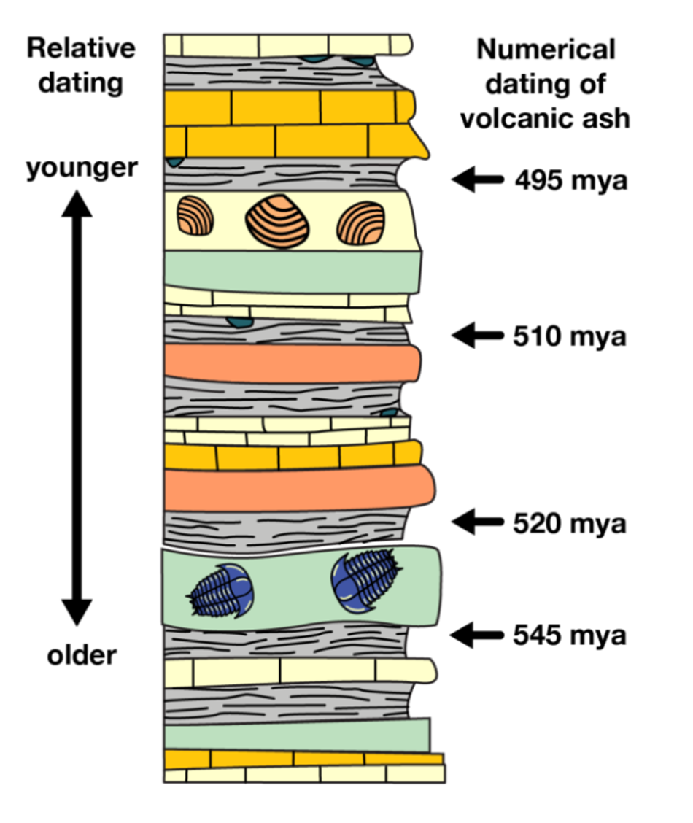
Suggest Approximate ages for:





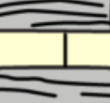



Layers of Strata

Extension: Research and suggest reasons why relative dating sometimes doesn’t work

In your own words, briefly describe what Radiometric dating is, and how it is different to Relative dating:

Looking at the list below, classify them into each column based on whether you would use Carbon-14 dating, or Uranium-Lead dating:

Carbon-14 |  | Uranium-Lead

Igneous Rocks Bones from a Neandertal Ancient Cave Painting

Precious Gem Stones (e.g. Diamonds) Remains of Ancient Plants

Lunar samples brought back from the moon

Remains of Ancient Plants Zircon minerals within rocks

8ES 11c Dinosaur Top Trumps
Research Activity:
- In your group you are to design three Dinosaur top trump cards.
- The categories on each card must include:
  - You must include the Period (Cretaceous, Jurassic, Triassic - including the age of this Period in MYA) - must have one from each period
  - State whether it was a carnivore or herbivore - must have at least one each
  - When it was discovered
  - How many fossils have been found - in full skeletons
  - Height - in m
  - Weight - in kg
- You must also have a short summary statement as shown below.

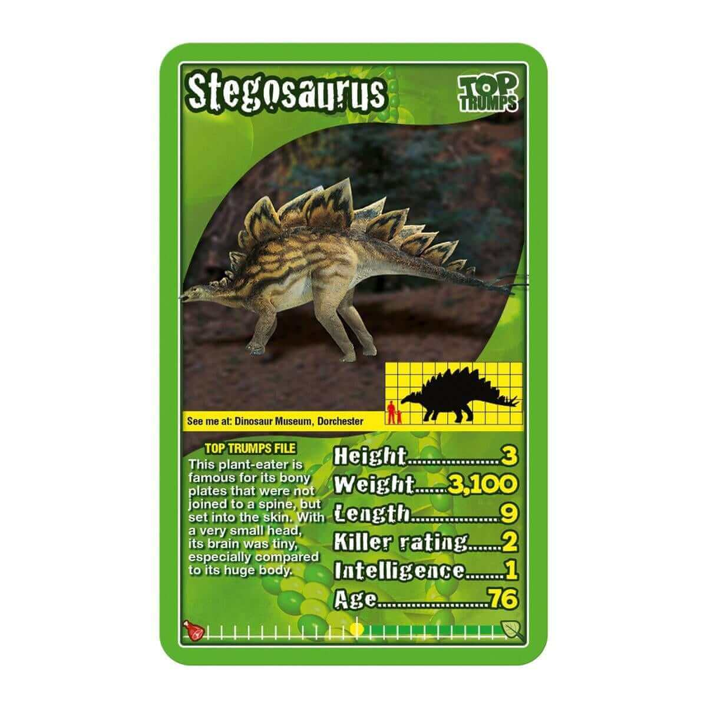

8ES 12a Extinction Events

What denotes a mass extinction event?

What is often used to measure extinction rates? Why?

What is background extinction?

What is the difference between the magnitude of extinction and the rate of extinction?

What is a common outcome and cause of an extinction event?

What is speciation?

8ES 12b Causes of Extinction Events

- Climate Change:
Cause: Changes in long-term climate patterns, such as global warming or cooling, can occur due to factors like volcanic activity, variations in solar radiation, or changes in atmospheric composition.
Effect: Shifts in temperature and precipitation patterns can disrupt ecosystems, leading to habitat loss, altered species distributions, and changes in food availability. Many species may struggle to adapt to these changes, resulting in reduced populations or extinction.

- Asteroid or Comet Impacts:
Cause: Large asteroids or comets colliding with Earth can release massive amounts of energy, causing widespread devastation and environmental changes.
Effect: The impact can trigger fires, release dust and debris into the atmosphere, cause tsunamis, and result in a significant climate change due to the blocking of sunlight. These effects can lead to the extinction of many species, both on land and in water.

- Volcanic Activity:
Cause: Intense volcanic eruptions can release vast quantities of volcanic gases, ash, and other materials into the atmosphere.
Effect: Volcanic activity can contribute to climate change by releasing greenhouse gases like carbon dioxide and sulfur dioxide. Additionally, ash clouds can block sunlight, leading to cooling effects. The combination of these factors can disrupt ecosystems, impact food chains, and contribute to species extinctions.

- Changes in Sea Levels:
Cause: Sea levels can change over time due to factors such as melting ice caps, tectonic activity, or variations in Earth's orbit and axial tilt.
Effect: Rising sea levels can result in the flooding and loss of coastal habitats, affecting marine and terrestrial species. Conversely, falling sea levels can fragment aquatic habitats and impact species dependent on specific water depths. These changes can lead to population declines and, in extreme cases, extinctions.

- Loss of Biodiversity and Habitat Destruction:
Cause: Human activities, such as deforestation, habitat destruction, pollution, and overexploitation of resources, can lead to significant biodiversity loss.
Effect: The loss of habitats and reduction in species diversity can disrupt ecosystems, decrease ecosystem resilience, and negatively impact the interconnected web of life. The extinction of one species can have cascading effects on other organisms within the ecosystem, potentially leading to further extinctions.
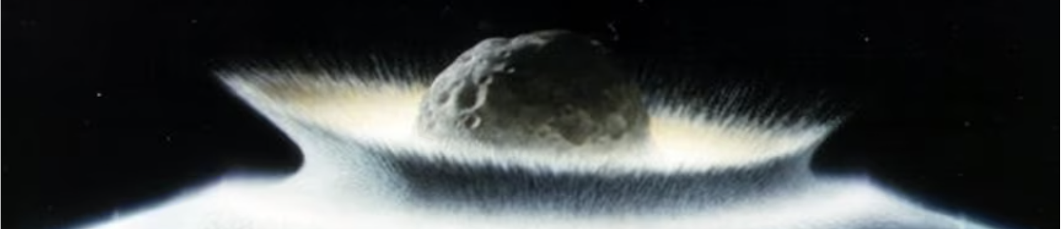

Activity: Using the information above make a summary of the types of events that could cause a mass extinction. List the effects of this event and give a rating (1-5) of the likelihood of this event occurring. Add any other research you like.

Extinction Cause | Effect | Likelihood

8ES 12c Mass Extinction Events Research
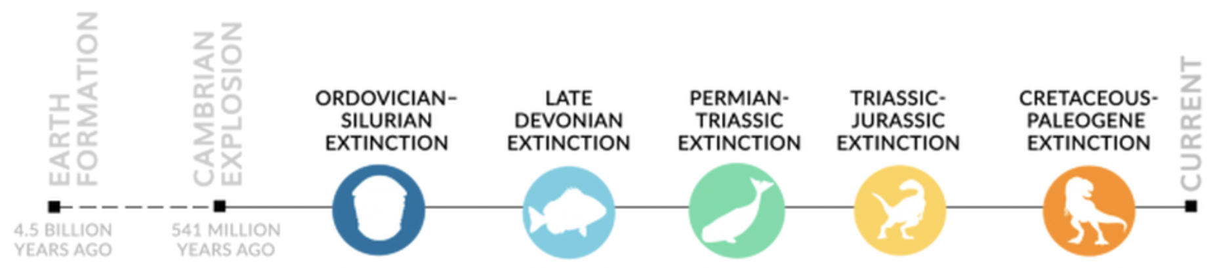

In your group, choose one of the known extinction events and make a slide including the following information:
- When it occurred (in MYA)
- What caused it
- What kind of life went extinct
- How/when it ended

Extension: Will there be a 6th mass extinction? Why or why not? When and how may it occur?

8ES 13a Ice Ages
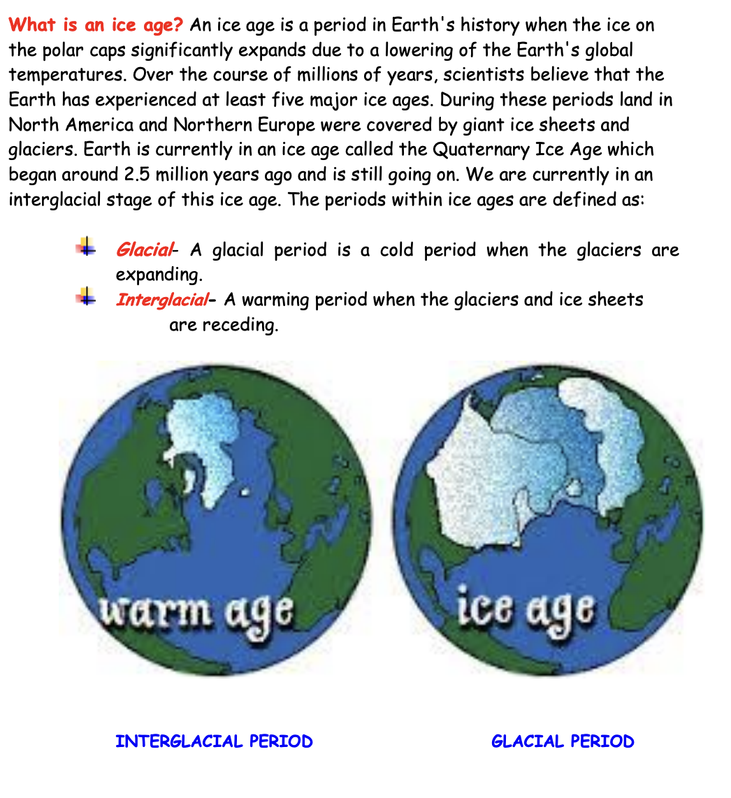
Earth System Research Laboratories Global Monitoring Laboratory. (n.d.). Problem Solving Activity: What Causes Ice Ages? Retrieved March 4, 2024, from https://gml.noaa.gov/outreach/info_activities/pdfs/PSA_ice_ages.pdf
Write your own definition of an ice age:

8ES 13b Causes/Effects of Ice Ages
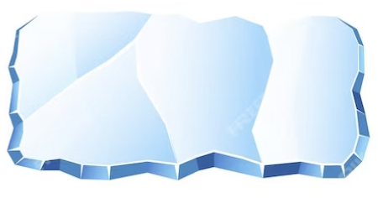

Amount of Sunlight:


Activity:
Write down the details of each potential cause for Ice ages as discussed by your teacher

Atmospheric Composition:

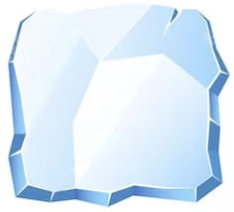

Plate Tectonics:

Effects of an Ice Age: Fill in the missing words

Inland lakes and deep valleys can be made as _____________ drop allowing ________ to also carve out the landscape and change the topographic features.
This is an example of ____________ effects of ice ages.

Some animals thrive during an ice age while others go __________. The change in global temperatures will also cause mass migrations and may force _________. Overall there will be a very large change in ____________

Extinct rivers biodiversity
Geological Sea-levels adaptations

Evidence for Ice Ages
Write down a definition and example of each type of evidence
Geological:

Chemical:

Paleontological:

8ES 14a Rise of the Mammals

Watch the video From the Fall of Dinos to the Rise of Humans and answer the following questions:

What is a stem animal? _____________________________________________________________________________
_____________________________________________________________________________

What era are we in now? When did it start? _____________________________________________________________________________
_____________________________________________________________________________

What was the K-P (also known as K-T) extinction event that ended the cretaceous period? _____________________________________________________________________________
_____________________________________________________________________________

What opportunities arose from the mass extinctions caused by the K-P event for the surviving life forms? _____________________________________________________________________________
_____________________________________________________________________________

What was the main diet for most early mammals? __________________________________________________________________________________________________________________________________________________________

What is a key feature of True Primates? _____________________________________________________________________________
_____________________________________________________________________________

A lot of mammals went extinct about 49 MYA. What caused this? _____________________________________________________________________________
_____________________________________________________________________________

When did old world monkeys first appear? _____________________________________________________________________________
_____________________________________________________________________________

Where did the first apes evolve? And what were some of their defining traits? _____________________________________________________________________________
_____________________________________________________________________________

When did the genetic lineage of modern humans first appear? And when did the first Hominims first appear? _____________________________________________________________________________
_____________________________________________________________________________

What ecosystem did hominims prefer? _____________________________________________________________________________
_____________________________________________________________________________

What current period are we in? _____________________________________________________________________________
_____________________________________________________________________________

Extension: Research what may be some of the main geological changes that supported the

rise of humans:

8ES 14b Adaptive Word Cloud

Mammal Adaptations that led to success

8ES 14c Intelligence

Research: Intelligence is a very difficult trait to measure, particularly across species. Compile a list of the top 10 most intelligent animals and how scientists measured their intelligence.

 | Animal | Intelligence Measure
1
2
3
4
5
6
7
8
9
10

Practical: In groups rotate around the room at your teachers instructions and try to
complete each of the intelligence test activities. Make sure you record your results!

8ES 15a Evolution of Humans
Evolution through Natural Selection
Write your own definition of Natural Selection here: |  | Write your own definition of Evolution here:

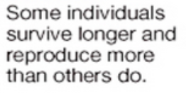
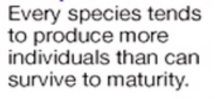
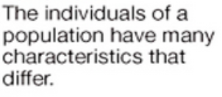
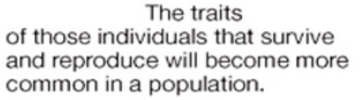
Draw a line from the description to the stage of evolution below:

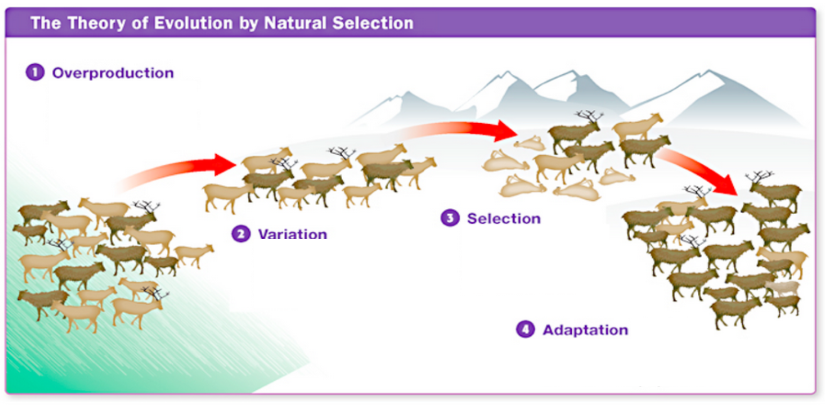

8ES 15b Evidence for Human Evolution

Find 3 pieces of evidence that support the idea of human evolution:

1:

2:

3:

Extension: Why do you think some people do not believe in evolution?

8ES 15c Timeline and Major Milestones
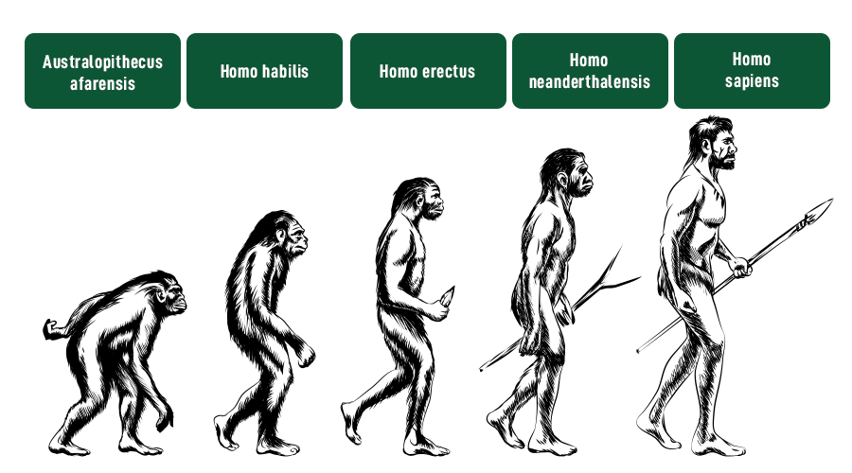

Jain, S. (2024, February 14). Human Evolution - History & Stages of Human Evolution. GeeksforGeeks. Retrieved March 11, 2024, from https://www.geeksforgeeks.org/human-evolution-stages/

Activity: Your group must write up an information sheet on one of the stages of the evolution of Homo Sapiens listed above. Your sheet must include:
- Approximate age of species
- Key anatomical traits
- Key behavioural traits
- Advantages of these traits
- Evidence for this species
- (A picture)

